Data description:

We have data in 3 different excel sheets. I have imported the data into the Jupyter notebook using the Pandas library. The 3 datasets and their respective columns are -

**Customers** – CustomerID, State, Salary, Gender, Smoker, Age, Occupation

**PolicyDetails** – PolicyID, CustomerID, Agent, Elimination Period, Income Replacement percent, Monthly Benefit, Annualized premium, product, policy effective date

**Claims** – PolicyID, Date of Loss, Diagnosis Category, Length of disability, Fraud, Amount paid, Amount recovered

|  |  |
| --- | --- |
| PolicyID | A unique ID identifying each policy |
| CustomerID | A unique ID identifying each insured |
| Gender | 1=Male, 0=Female |
| Smoker | 1=Smoker, 0=Non-smoker |
| Elimination Period | The number of days after the date of loss (i.e., the date of the accident, injury, or illness) that the policy goes into effect |
| Income Replacement Percent | The percent of your income the policy replaces |
| Monthly Benefit | The monthly amount the insured receives while on disability |
| Annualized Premium | The annualized amount of premium the insured pays to us |
| Latitude | The latitude of the insured's home address |
| Longitude | The longitude of the insured's home address |
| Product | The product the insured purchased (Disability or Life) |
| Policy Effective Date | The effective date of the policy |
| Date of Loss | This the date the accident, injury or illness occurred or was diagnosed |
| Diagnosis Category | The type of diagnosis |
| Length of Disability (in Days) | The number of days the insured collected disability |
| Fraud | An indicator of fraud. If "Yes", the claim was found to be fraudulent. If "No" the claim was not found to be fraudulent |
| Amount Paid | The amount of money the company paid the insured for the claim |
| Amount Recovered | The amount of money the company recovered on a fraudulent claim |
| Fraud | 1=Confirmed fraud, 0=No fraud confirmed |

I inner joined customers and policydetails on ‘CustomerID’ and then, inner joined this data with Claims on ‘PolicyID’.

Data Preparation:

I filtered the policy data where we have cases only related to ‘Disability’ insurance. There are a few duplicated rows in the final data. I removed the duplicates and kept the first instance only. Later, I dropped irrelevant columns like PolicyID, CustomerID, date variables, etc. The final data has 30,838 rows and 12 columns. There are no null values. But there is a class imbalance.

|  |  |
| --- | --- |
| Fraud | 14.78% |
| Non-Fraud | 85.22% |

I want to see if fraudsters take advantage of the system and claim to have a longer disability period. But the distribution of the length of disability in days for fraudsters and non-fraudsters shows no significant difference. They have almost similar means and similar distribution.

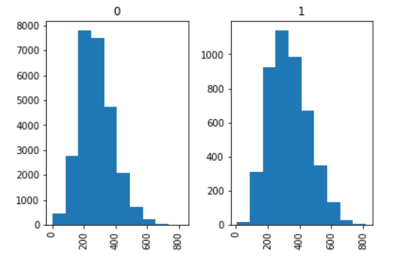

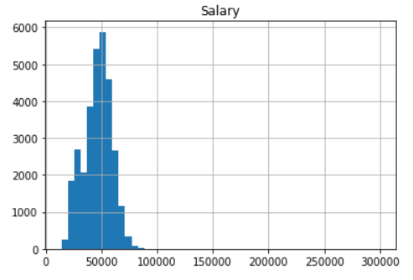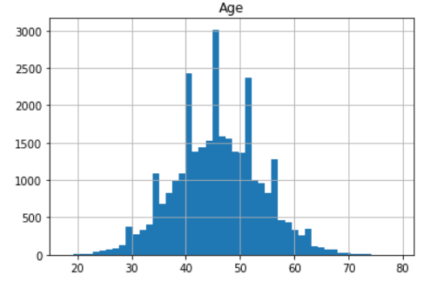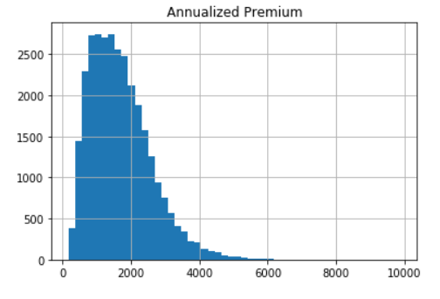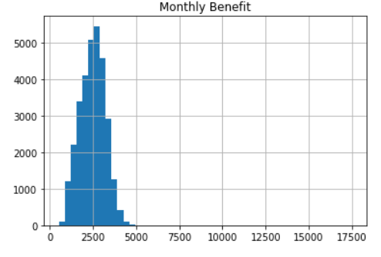

The distributions of the continuous variables are kind of normal in the data. But the scale of measurement is very different. This will cause an undue extra impact of some variables compared to the others while modeling some algorithms. So, it is advised to standardize the continuous variables. I used standardscaler in sklearn to standardize the variables.

Variables occupation, agent, elimination period and income replacement percent are categorical in nature. Using categorical variables as it is will cause problems in modeling. So, I created dummy variables using pandas. I dropped the original variables after the dummies were created. Now that the data is ready, I separated them into independent and target variables and split them to 80%:20% training and validation split. The purpose of creating a validation set is to ensure that our model is not overfitting.



Sampling:

To address the class imbalance issue, I used SMOTE oversampling followed by Tomek links cleaning. This will synthetically create new training instances of one level to match that of the other level. Cleaning is done by Tomek links. Now, the training data has 40,738 rows of equally distributed Fraud proportion.

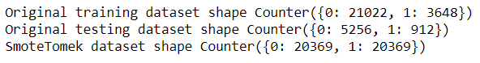

Model: Naïve Bayes Classifier

**Naive Bayes** is an extremely fast algorithm relative to other [classification algorithms](https://courses.analyticsvidhya.com/courses/introduction-to-data-science-2/?utm_source=blog&utm_medium=6stepsnaivebayesarticle). It is a [classification technique](https://courses.analyticsvidhya.com/courses/introduction-to-data-science-2/?utm_source=blog&utm_medium=6stepsnaivebayesarticle) based on Bayes’ Theorem with an assumption of independence among predictors. In simple terms, a Naive Bayes classifier assumes that the presence of a feature in a class is unrelated to the presence of any other feature. In Gaussian Naive Bayes, each feature is assumed to be distributed normally.

I ran Gaussian Naïve Bayes on the SMOTETomek over sampled training data and validated the model in the validation data. The results are published in the table below.

|  |  |  |
| --- | --- | --- |
| Metrics in % | Training data | Validation Data |
| Accuracy | 66.71 | 51.11 |
| Recall | 87 | 83 |
| Precision | 62 | 21 |
| AUC | 72 | 69 |
| F1 Score | 72 | 34 |

The accuracy of the training data is 66.71%, but it is low on validation data at 51.1%. This low accuracy on training data could be that the model is overfitting on the training data and is not that great at capturing the true trend. But the validation data is having a class imbalance. So, accuracy might not be the correct metric to look at. Sensitivity on the training and validation data is great. It is the most important metric to look at in this particular scenario. The validation precision has dropped compared to the training precision. This means our confidence in catching true positives has dropped and our model is flagging more other cases as true positives. The AUC of 69% says that the classifier does a decent, but not so great job of classifying fraud and non-fraud cases.

We can find alter the cut-offs to make the model highly sensitive in finding the true positives, but that is also increasing the false positives. Machine learning cant help beyond this point. It requires a business understanding for evaluation between what is the desired sensitivity of the model and what percent of false positives we can afford to achieve that sensitivity.

Overall, I find a need to bring more data to improve the accuracy of the model. More features that will account for Fraud cases need to be brought in the model.

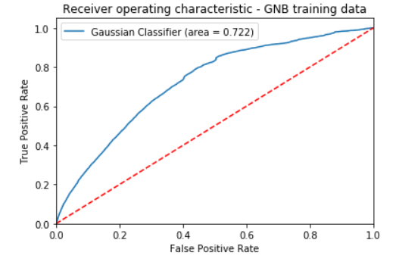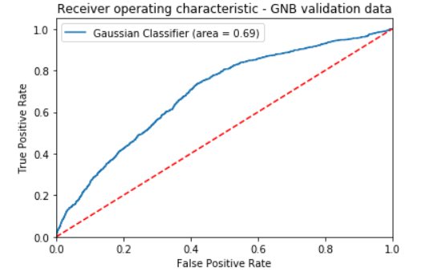

K Nearest Neighbors:

KNN is a supervised parametric classification algorithm, just like GNB, but it doesn’t work on Bayes’ theorem. KNN models work by taking a data point and looking at the ‘k’ closest labeled data points. The data point is then assigned the label of the majority of the ‘k’ closest points. While this seems simple, several methods are available to compute the closeness. Euclidean distance is a common metric that is used for continuous variables. Since the data are seen how far each point is from another, large variables have an undue impact. So, all the variables need to be standardized before running the model.

Choosing the optimal value of K is an optimization problem, as well as a part of the bias-variance trade-off. If we choose a very low value of k, the classifier will have very low bias but will be highly flexible. A high k-value will yield results that have a high bias, but that is stable to data fluctuations. To subjectively decide k value, I have plotted the validation accuracy, recall, and sensitivity of the model built over several values of k from 1 to 100. Then, I decided on a k value of 15 based on judgment.

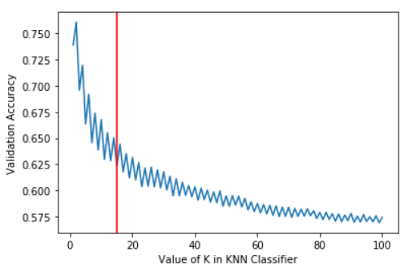 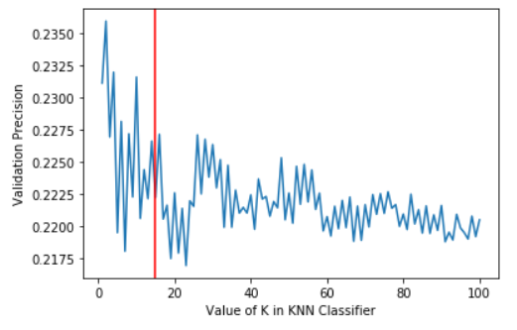

I choose k = 15 because I think it is where the recall curve has started becoming flat, whilst maintaining good accuracy and precision.

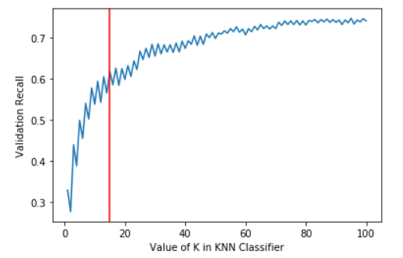

Then, I built the final model with k =15 and calculated the metrics of importance for both training and validation data.

|  |  |  |
| --- | --- | --- |
| Metrics in % | Training data | Validation Data |
| Accuracy | 80.5 | 62.35 |
| Recall | 93 | 62 |
| Precision | 74 | 22 |
| AUC | 81 | 62 |
| F1 Score | 83 | 33 |

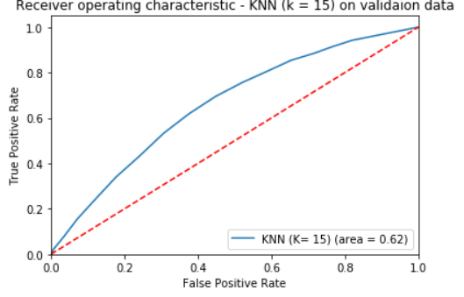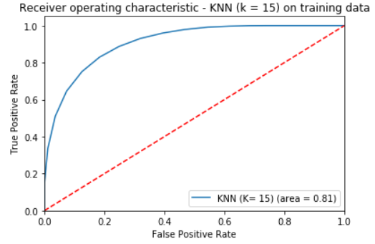

Looking at the model performance statistics, we can say that the classifier probably is not doing any better than the simple GNB classifier, even though we are using a good k value. KNN (k=15) may be having a higher validation recall than GNB, but in terms of accuracy, precision, and AUC, it is falling behind.

Support Vector Machine Classifier:

SVM is a powerful supervised machine learning model that utilizes the natural separation of the data in the feature space to identify target variable classes. The classifier separates data points using a hyperplane with the largest amount of margin. That's why an SVM classifier is also known as a discriminative classifier. SVM finds an optimal hyperplane which helps in classifying new data points. Support vectors are the data points, which are closest to the hyperplane. These points will define the separating line better by calculating margins. These points are more relevant to the construction of the classifier.  The kernel specified projects the non-linearly separable data in lower dimensions to linearly separable data in higher dimensions in such a way that data points belonging to different classes are allocated to different dimensions.

I have trained the SVM model with different kernel functions on the SMOTETomek oversampled training data and validated it on the validation data. Here are the results.

|  |  |  |  |  |  |
| --- | --- | --- | --- | --- | --- |
| SVM (Sigmoid, C = 0.1) | | | SVM (Sigmoid, C = 0.01) | | |
| Metrics in % | Training data | Validation Data | Metrics in % | Training data | Validation Data |
| Accuracy | 55 | 55 | Accuracy | 62 | 60 |
| Recall | 55 | 56 | Recall | 63 | 59 |
| Precision | 55 | 18 | Precision | 61 | 20 |
| F1 Score | 55 | 27 | F1 Score | 62 | 30 |
| SVM (RBF, C = 0.1) | | | SVM (RBF, C = 0.3) | | |
| Metrics in % | Training data | Validation Data | Metrics in % | Training data | Validation Data |
| Accuracy | 69.3 | 60.5 | Accuracy | 70 | 61.3 |
| Recall | 79 | 75 | Recall | 80 | 73 |
| Precision | 66 | 24 | Precision | 67 | 24 |
| F1 Score | 72 | 36 | F1 Score | 73 | 36 |

RBF kernels have higher validation accuracy than sigmoid kernels for 2 different values of the regularization parameter. Not only the accuracy but also validation recall, precision, and f1 score are higher for sigmoid kernels. This means that data are separable in higher dimensions in a radial direction than in a sigmoid way. We are managing to get higher validation recall but not precision. That means that the models are tagging more cases as positives, and only around a quarter of them are turning out to be true positives. It is a struggle between sensitivity and precision in all the models built on GNB, SVM, and KNN. This means that there is a need to bring additional features that help us better predict fraud.

Logistic Regression:

Logistic Regression is a supervised parametric method that is used for classification purposes. I have built 3 models using 3 different regularization techniques in python, on the SMOTETomek oversampled data and validated the results on validation data. The results are as below. By using regularization, all 3 models are not overfitting. This can be seen from almost the same training and validation accuracy. The AUC on validation data is 0.73 which is the highest among all models built so far. The validation recall is also great. Precision followed the same pattern as previous models’ precision.

|  |  |  |  |  |  |  |
| --- | --- | --- | --- | --- | --- | --- |
| L1 Regularizer | | | L2 Regularizer | | Elastic Net Regularizer | |
| Metrics in % | Training data | Validation Data | Training data | Validation Data | Training data | Validation Data |
| Accuracy | 68.5 | 64.5 | 68.5 | 64.6 | 68.5 | 64.6 |
| Recall | 73 | 73 | 73 | 73 | 73 | 73 |
| Precision | 67 | 26 | 67 | 26 | 67 | 26 |
| AUC | 75 | 73 | 75 | 73 | 76 | 73 |
| F1 Score | 70 | 38 | 70 | 38 | 70 | 38 |

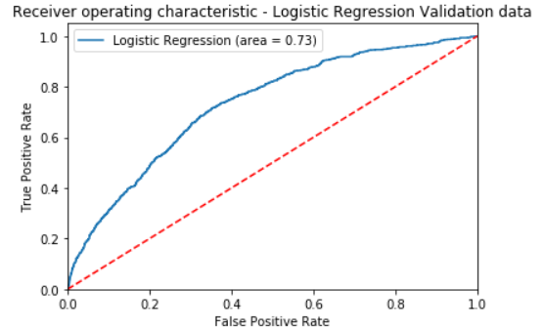

Random Forests:

RF is a set of decision trees built on bagged samples of the data. A single, full-grown decision tree may have low bias but is highly flexible that it may not generalize on test data. To address this inherent drawback of decision trees, several such trees are built parallelly and their estimates are averaged. This averaging will reduce the variance of the estimate. This idea is derived from the central limit theorem.

|  |  |  |
| --- | --- | --- |
| Random Forest (500 trees) | | |
| Metrics in % | Training data | Validation Data |
| Accuracy | 100 | 77 |
| Recall | 100 | 34 |
| Precision | 100 | 27 |
| AUC | 100 | 69.2 |
| F1 Score | 100 | 30 |

I built an RF model with 500 estimators on the SMOTETomek oversampled data and validated it on training data.

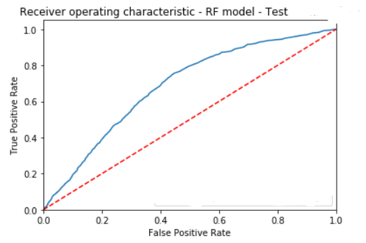

The model performed exceptionally well on the training data and its accuracy on the validation data is the highest too. But the precision and recall are low. That means the model is better capturing the true negatives than true positives. Nonetheless, the model performed at par with other models.

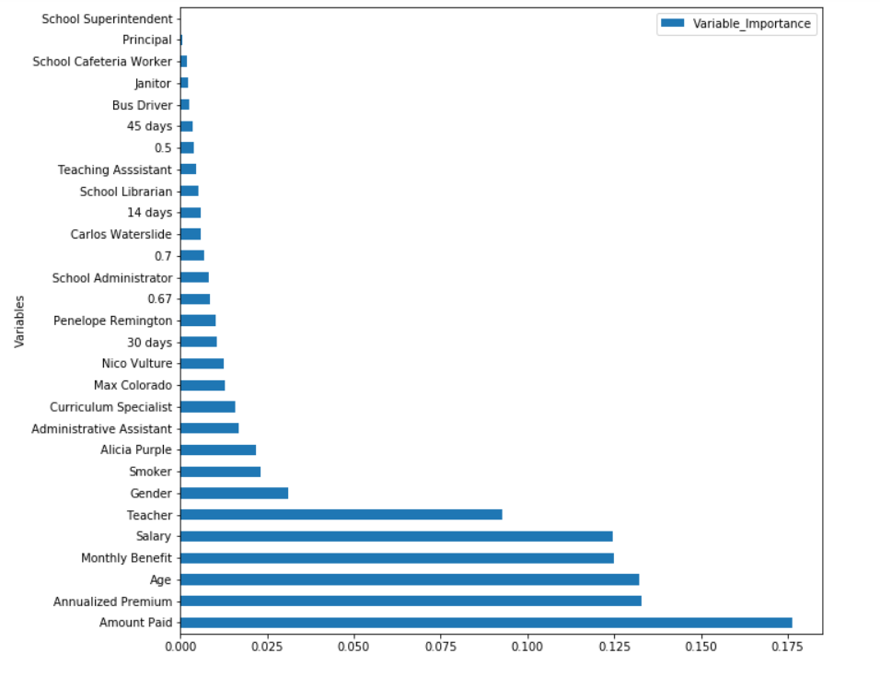

The variable importance of the features is shown in the above picture. It can be seen that continuous variables like age, amount paid, and annualized premium have the highest information about fraud cases followed by monthly benefit and salary.

I have performed 10-fold cross-validation on the random forest model with 100 estimators. I did SMOTETomek oversampling within the cross-validation i.e., each of the 9 folds will be oversampled and the remaining fold will be sued for validation. The validation recall for 10 folds is in the following table.

|  |  |
| --- | --- |
| Fold 1 | 22.59% |
| Fold 2 | 32.89% |
| Fold 3 | 34.21% |
| Fold 4 | 33.11% |
| Fold 5 | 35.53% |
| Fold 6 | 36.84% |
| Fold 7 | 37.28% |
| Fold 8 | 33.11% |
| Fold 9 | 32.46% |
| Fold 10 | 33.55% |

Gradient Boosting:

GB is a boosting procedure that is usually done on decision trees, to improve the bias of the model, at the cost of overfitting. GB trees are built sequentially, one after another and each tree will learn the mistakes from its predecessor and tries to correct them. This will build a series of trees and the final estimates are very accurate.

The learning rate is a hyperparameter in GB models. So, I ran a couple of GB models for several values of learning rate from 0.01 to 1 and decided to see what value of learning rate gives us the best recall and validation accuracy. I choose 0.9 because it gives me the least difference between training and validation accuracy (least overfitting) and the highest recall.

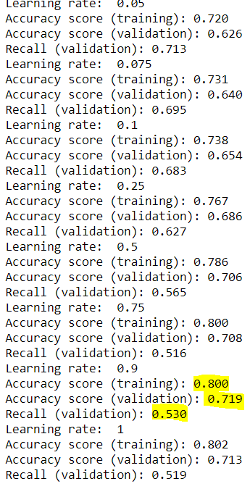

|  |  |  |
| --- | --- | --- |
| GB | features = sqrt | features = 2 |
| Metrics in % | Validation Data | Validation Data |
| Accuracy | 72 | 69 |
| Recall | 48 | 53 |
| Precision | 26 | 25 |
| AUC | 69 | 69 |
| F1 Score | 34 | 34 |

I built 2 GB models for 2 different settings. One model was given max_features = square root (total features) and the other model was given only 2 features at any split. The common settings were learning rate = 0.9 and subsample is 0.5.

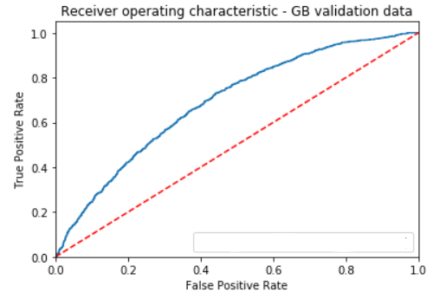

When we input more features into the model, the validation accuracy and precision improved but the recall went down. This was a compromise we saw in random forests as well. The AUC is 0.69. The GB model performed the same as other models.

By performing several models, I concluded that there is a need to bring more features into the picture. We have exhausted all the information brought from the existing variables and we peaked our validation statistics in RF and Logistic Regression models. The results might differ a bit based on the random split that divided the data to training and validation data, but that difference shall be minimal as we used stratified split to divide the data.